Date:01/12/2021

**Program - 2**

**Aim:**

Perform SVD(Singular Value Decomposition)

**Program:**

from numpy import array

from scipy.linalg import svd

a=array([[1,2,3,4],[7,8,3,5],[4,6,9,10]])

print(a)

u,s,vt=svd(a)

print("Decomposed Matrix\n",u)

print("Inverse Matrix\n",s)

print("Transpose matrix\n",vt)

**OUTPUT**

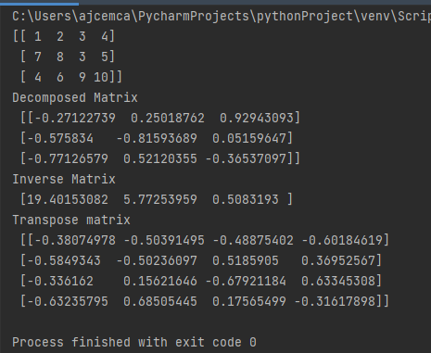

**Program - 3**

**Aim:**

Program to implement k-NN classification using any standard dataset available in the public domain and find the accuracy of the algorithm.

**Program:**

from sklearn.neighbors import KNeighborsClassifier

from sklearn.model_selection import train_test_split

from sklearn.datasets import load_iris

from sklearn.metrics import accuracy_score

idata=load_iris()

x=idata.data

y=idata.target

x_train,x_test,y_train,y_test=train_test_split( x,y,test_size=0.3,random_state=55)

knn=KNeighborsClassifier(n_neighbors=3)

knn.fit(x_train,y_train)

y_p=knn.predict(x_test)

print(knn.predict(x_test))

print(“Accuracy score : ”,accuracy_score(y_test,y_p))

**OUTPUT**

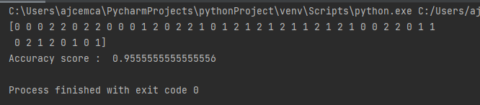

**Program - 4**

**Aim:**

Program to implement k-NN classification using any random data set without using inbuilt packages.

from math import sqrt

def e_dis(r1,r2):

dist=0.0

for i in range(len(r1)-1):

dist+=(r1[i]-r2[i])**2

return sqrt(dist)

def get_ne(train,test_row,num_neig):

distances=list()

for train_row in train:

dist=e_dis(test_row,train_row)

distances.append([test_row,train_row])

distances.sort(key=lambda tup:tup[1])

neighbors=list()

for i in range(num_neig):

neighbors.append(distances[i][0])

return neighbors

def predict_classif(train,test_row,num_neig):

neighbors = get_ne(train,test_row,num_neig)

out_val=[row[-1] for row in neighbors]

prediction=max(set(out_val),key=out_val.count)

return prediction

dataset=[[2.734,2.55,0],

[1.45,3.36,0],

[2.334, 2.355, 0],

[1.45, 3.36, 0],

[2.334, 2.55, 0],

[1.45, 3.336, 0],

[3.334, 3.55, 1],

[1.45, 3.36, 1],

[3.734, 4.55, 1],

[3.45, 4.36, 1],

[4.734, 5.55, 1],

[3.45, 5.36, 1]]

prediction=predict_classif(dataset,dataset[0],3)

print('Excpected %d,Got %d'%(dataset[0][-1],prediction))

**OUTPUT**

